

ELEC4848 Senior Design Project 2025-2026
Department of Electrical and Electronic Engineering

Chan Yu Sing (3035930345)
Computing with diffraction
Supervisor: Prof. Kenneth Wong
Second Examiner: Prof. Edmund Lam

Table of Contents
Section | Page
1. Introduction | 3-4
2. Theoretical Principles | 5-7
3. System Design | 8-11
4. Implementation Progress | 12-16
5. Challenges and Solutions | 17
6. Work Distribution | 18
7. References | 19-20

Summary
This project implements an Optical Neural Network (ONN) for handwritten digit classification using LCD screens as trainable amplitude modulators. Unlike electronic neural networks that rely on transistor-based computation, ONNs perform inference through light propagation, offering potential advantages in speed and energy efficiency.
The system uses two LCD layers with 200×200 pixel resolution, operating at 532nm wavelength. Light propagation between layers is simulated using the Angular Spectrum method. MNIST digit images are resized to 140×140 pixels and center-padded to match the LCD resolution. Classification is performed by measuring output light intensity patterns.
A differentiable simulation framework was developed in PyTorch, enabling end-to-end gradient-based training. The framework models realistic LCD effects including fill factor, contrast limits, and binary quantization. Three detection methods were compared: zone-based, center-based, and binary encoding.
The binary encoding detection method achieved 76.86% accuracy on MNIST. Trained amplitude masks show structured patterns indicating learned spatial features. Hardware assembly and real-world optical testing are planned for the next phase.

1. Introduction

1.1 Background

Electronic neural networks have achieved remarkable success in image classification, speech recognition, and many other tasks. However, they face two fundamental limitations: speed and energy consumption. A typical neural network requires billions of multiply-accumulate operations per inference. Each operation consumes power and takes time.
Optical computing offers an alternative. Light travels at 3x10⁸ m/s. When light passes through a modulating layer, the entire wavefront is processed in parallel—millions of pixels simultaneously. The computation happens passively as light propagates; no transistors switch, no energy is consumed beyond the light source itself.
In 2018, Lin et al. demonstrated that diffractive optical elements could perform machine learning tasks [1]. Their Diffractive Deep Neural Network (D2NN) achieved 91.75% accuracy on handwritten digit classification using 3D-printed phase masks. This work sparked renewed interest in optical neural networks for low-latency, low-power inference [2][4].

1.2 Optical Neural Networks
A Diffractive Deep Neural Network consists of multiple diffractive layers separated by free space. Each layer modulates the incoming light—either its amplitude (intensity) or phase (wavefront shape). As light propagates between layers, diffraction causes interference patterns that mix spatial information. The output intensity at specific detector locations determines the classification result.
The key insight is that diffraction performs a physical Fourier transform [10]. Combined with element-wise modulation at each layer, the system can learn complex input-output mappings. Training occurs in simulation: gradients flow backward through a differentiable physics model, updating the modulation patterns. Once trained, the patterns are fixed and deployed to physical hardware.

1.3 Why LCD?
Building an optical neural network requires spatial light modulators (SLMs) to create the diffractive layers. Several options exist:
1. 3D-printed or lithography masks : Permanent patterns, cannot be reconfigured
2. Digital Micromirror Devices (DMD): Binary modulation, expensive, complex optics
3. Phase SLMs: Full phase control, but cost $10,000+ per unit
4. LCD screens: Amplitude modulation, cheap, programmable
This project uses LCD screens for three reasons. First, cost: a 200×200 pixel monochrome LCD costs under $50. Second, availability: commercial LCD modules are readily accessible. Third, programmability: patterns can be updated electronically, allowing rapid experimentation.
LCD screens have limitations. They modulate amplitude only, not phase. Their fill factor is below 100% due to pixel gaps. Contrast ratio is limited—pixels cannot fully block or fully transmit light. Some LCD types support only binary (on/off) states.

1.4 Project Objectives
This project aims to build and validate an LCD-based optical neural network for digit classification. The objectives are:
1. Develop a simulation framework
- Implement Angular Spectrum Method for accurate light propagation [10]
- Model realistic LCD effects: fill factor, contrast limits, binary quantization
- Build a differentiable model in PyTorch for end-to-end training [12]
2. Train amplitude masks for MNIST classification
- Optimize two-layer amplitude masks using gradient descent
- Compare detection methods: zone-based, center-based, and binary encoding
- Achieve reasonable classification accuracy in simulation on MNIST dataset [11]
3. Build hardware prototype
- Assemble optical system with laser, LCD screens, and camera
- Deploy trained masks to physical LCD hardware
- Validate simulation predictions with real measurements

2. Theoretical Principles

2.1 Light Propagation

2.1.1 Diffraction
When coherent light passes through an aperture or modulating element, it diffracts. The light wavefront spreads and interferes with itself, creating complex intensity patterns. This behavior is governed by the wavelength and propagation distance [10].

2.1.2 Angular Spectrum Method
The Angular Spectrum Method (ASM) simulates light propagation between optical layers [10]. The method decomposes an optical field into plane waves traveling at different angles. Each plane wave accumulates phase as it propagates. Recombining these waves yields the output field.
The propagation procedure is:
1. Compute 2D FFT of input electric field
2. Multiply by the transfer function (phase shift based on wavelength and distance)
3. Compute inverse FFT to get output electric field

2.2 Amplitude Modulation

2.2.1 LCD as Amplitude Modulator
The LCD screen controls light transmission at each pixel. The output electric field equals the input field multiplied by the transmission value T at each pixel. T ranges from 0 (block light, black pixel) to 1 (pass light, white pixel).

2.2.2 Amplitude vs Phase Modulation
Type | Controls | Hardware | This project
Amplitude | Light intensity | LCD | Yes
Phase | Light wavefront | Phase SLM | No
Phase modulation preserves energy since no light is blocked. However, phase SLMs cost over $10,000. Amplitude modulation with LCD is simpler and cheaper, though some light is absorbed.

2.2.3 Trainable Masks
The transmission values T(x,y) are the trainable parameters. They are initialized randomly, optimized via gradient descent, and stored as the learned optical weights.

2.3 Multi-Layer System

2.3.1 System Architecture
The optical path is:
Input LCD 1 (Mask 1) propagate 50mm LCD 2 (Mask 2) propagate Detector

2.3.2 Mathematical Model
For a 2-layer system:
1. Input field: square root of input image intensity
2. After Layer 1: input field multiplied by mask T1
3. After Propagation 1: apply ASM over distance z1
4. After Layer 2: multiply by mask T2
5. After Propagation 2: apply ASM over distance z2
6. Output intensity: square of the absolute value of the final electric field

2.3.3 Why Multiple Layers?
A single layer performs only element-wise multiplication—limited expressiveness. Multiple layers with diffraction between them mix spatial information nonlinearly [1].

2.4 Detection Methods
The output intensity pattern must be converted to class predictions. Three methods were implemented:

2.4.1 Zone-Based Detection
Divide the output plane into spatial zones, one per class. Sum the intensity in each zone to get the logit for that class. For MNIST with 10 classes, a 2x5 grid provides 10 zones.

2.4.2 Center-Based Detection
Sample intensity at a grid of points, then apply a linear classifier. The detection weights and bias are learnable, providing more flexibility.

2.4.3 Binary Encoding Detection
Use N zones and threshold each zone's intensity to produce a bit (0 or 1). The resulting bit pattern maps to a class via lookup table. This method is robust to intensity variations and creates sharp decision boundaries.

2.5 End-to-End Training

2.5.1 Differentiable Physics
All operations are implemented in PyTorch with automatic differentiation [12]. This includes FFT/IFFT operations, complex arithmetic, and intensity computation.

2.5.2 Training Procedure
1. Forward pass: Input image goes through physics simulation to produce output intensity
2. Loss computation: Cross-entropy between predicted and true class
3. Backward pass: Gradients flow through all optical layers
4. Update: Optimizer adjusts mask transmission values

3. System Design

3.1 Hardware Configuration

3.1.1 System Overview
The optical neural network arranges components in a linear optical path:
Laser (532nm) Collimator Input SLM (MNIST image) LCD Layer 1 (Mask 1) 50mm gap LCD Layer 2 (Mask 2) Camera (Detector)
A 532nm green laser provides coherent illumination. The input image is displayed on a spatial light modulator. Light then passes through two LCD layers that apply trained amplitude masks. A camera captures the output intensity pattern for classification.

3.1.2 Component Specifications
Component | Specification | Details
Light Source | 532nm green laser | Coherent, collimated beam
LCD Screen | 1.54" Monochrome Reflective LCD | Amplitude masks
Camera | Matching resolution | Intensity detection

3.1.3 LCD Specifications
Resolution: 200 x 200 pixels
Active Area: 27.66 mm x 27.66 mm
Pixel Pitch: 138.3 um
Type: Monochrome, reflective
Modulation: Amplitude (transmission control)

3.1.4 Optical Parameters
Wavelength:532 nm
Number of layers: 2
Layer spacing:50 mm
Total optical path:~150 mm

3.2 Software Architecture

3.2.1 Module Overview
The simulation software is organized into modular Python files:
- config.py: All hardware and training parameters
- data.py: MNIST dataset loading
- physics.py: Angular Spectrum Method propagation
- model.py: Optical Neural Network architecture
- train.py: Training pipeline
- visualize_propagation.py: Visualization tools

3.2.2 Module Responsibilities
Module | Purpose | Key Functions
config.py | Centralized configuration | LCD, light, training parameters
data.py | Dataset handling | MNIST loading, resizing, padding
physics.py | Optical simulation | Angular Spectrum propagation
model.py | Neural network | AmplitudeLayer, Detectors, ONN
train.py | Training pipeline | Training loop, checkpointing
visualize_propagation.py | Visualization | Light field and mask display

3.2.3 Key Design Decisions
1. Centralized configuration: All parameters in config.py for easy tuning
2. Differentiable physics: PyTorch enables end-to-end gradient-based training [12]
3. Modular detection: Zone, center, and binary detection methods are swappable
4. Realistic LCD modeling: Fill factor, contrast limits, and binary mode supported

3.3 Data Pipeline

3.3.1 Input Preprocessing
MNIST images are preprocessed to match LCD resolution [11]:
Original MNIST (28x28) -> Resize (140x140) -> Center Pad (200x200) -> Normalize [0, 1]
Stage | Input Size | Output Size | Method
Load | 28 x 28 | 28 x 28 | torchvision
Resize | 28 x 28 | 140 x 140 | Bilinear interpolation
Pad | 140 x 140 | 200 x 200 | Zero-padding (black border)
Normalize | [0, 255] | [0, 1] | Divide by 255
The digit is resized to 140x140 pixels, then centered on a 200x200 canvas with black padding. This ensures the digit occupies the central region of the LCD.

3.3.2 Data Split
Training: 60,000
Test:10,000

3.4 Training Configuration

3.4.1 Hyperparameters
Optimizer: Adam
Learning Rate: 0.02
Scheduler: CosineAnnealingLR
Batch Size: 64
Max Epochs: 100
Early Stopping: Patience = 10

3.4.2 Loss Function
Cross-entropy loss for multi-class classification. The loss compares the predicted class probabilities with the true one-hot label for each of the 10 digit classes.

3.4.3 Checkpointing
The training pipeline saves only the best model based on validation accuracy. Trained masks are exported as PNG images for display on physical LCDs. Training metadata (epoch, accuracy, configuration) is stored alongside the model.

4. Implementation Progress

4.1 Current Status
Physics simulation (ASM): Complete
LCD effects modeling: Complete
Differentiable model: Complete
Detection methods: Complete
Training pipeline: Complete
Visualization tools: Complete
Hardware assembly: In progress
Real-world testing: Planned
All simulation software is functional. The system can train amplitude masks and visualize light propagation. Hardware integration is the next phase.

4.2 Training Results
Three detection methods were compared using the same model architecture and training configuration.

4.2.1 Detection Method Comparison
Detection Method | Grid | Test Accuracy
Binary encoding | 3x3 | 76.86%
Center-based | 3x3 | 71.21%
Zone-based | 2x5 | 17.97%
Binary encoding achieved the best accuracy. Zone-based detection failed to converge—its loss remained nearly constant throughout training, indicating gradient issues.

4.3 Learned Amplitude Masks
The trained model produces two amplitude masks, one per LCD layer.
Resolution: 200 x 200 pixels
Value range: [0, 1]
Format: 8-bit grayscale PNG
Detection Method | Mask1 | Mask2
Binary encoding | 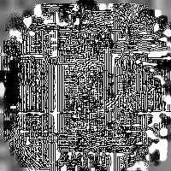 | 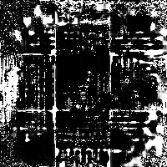
Center-based | 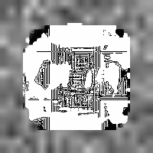 | 
Zone-based |  | 

4.4 Propagation Visualization
Light propagation through the trained ONN was visualized for sample digits.
Each visualization shows intensity and phase at each stage:
- Input image
- After Mask 1
- After Propagation 1
- After Mask 2
- Output (camera plane)

Binary encoding:
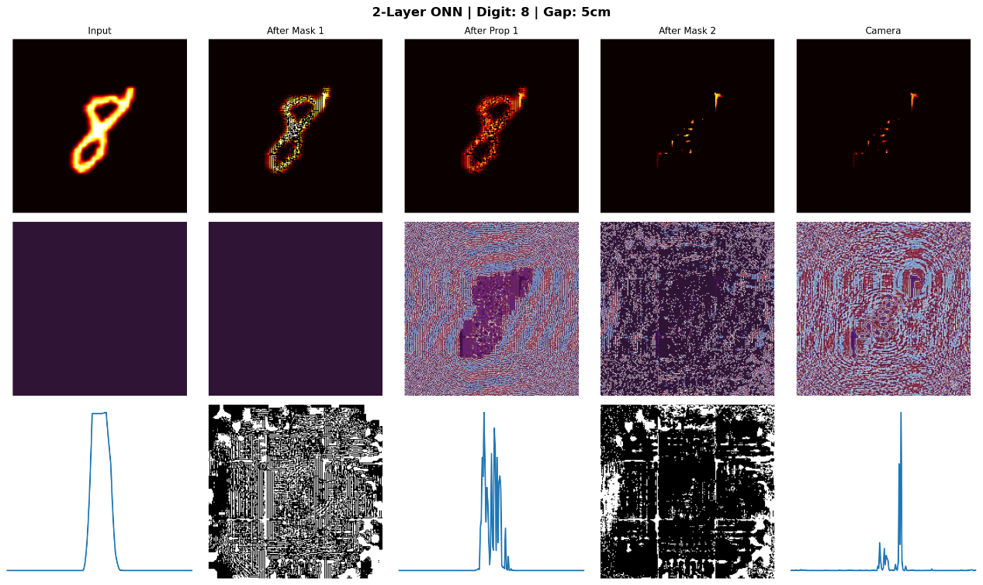

Center-based:
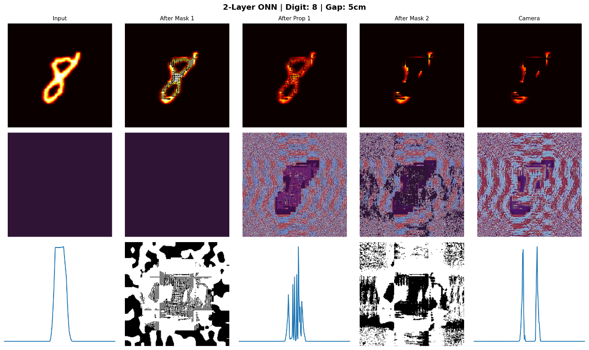

Zone-based:
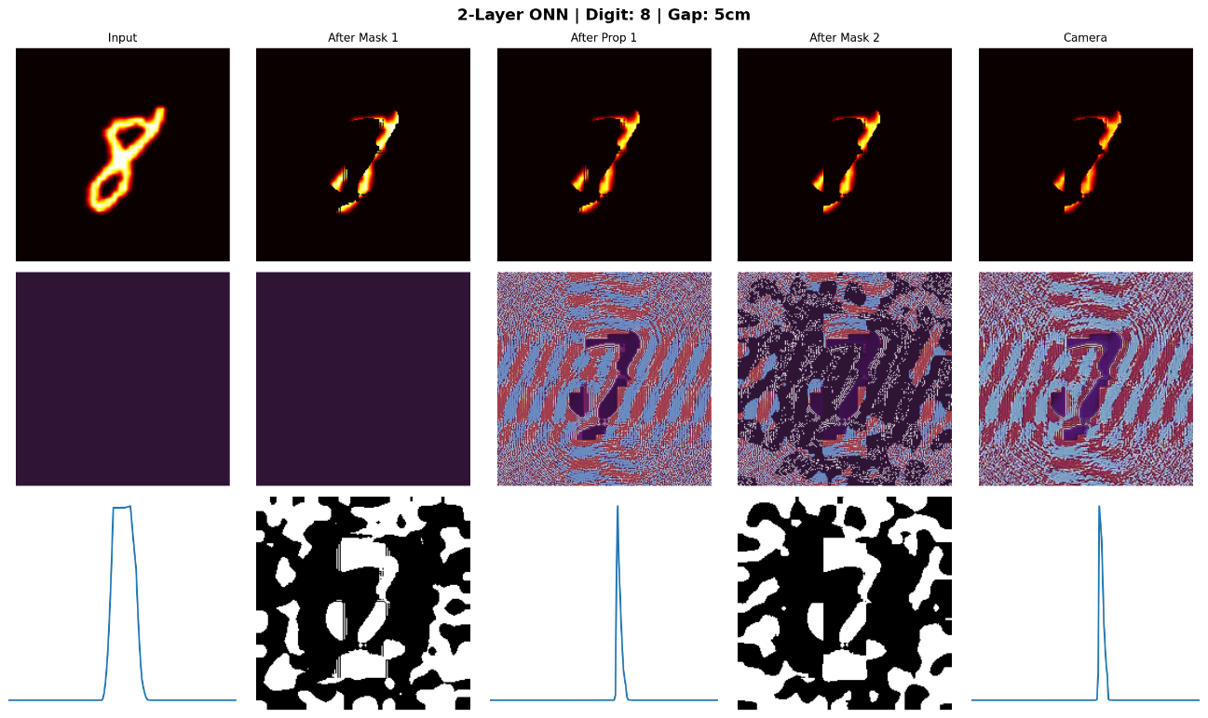

Different digits produce distinct output patterns. The masks create digit-specific light distributions that enable classification.

4.5 Summary
The simulation achieves 76.86% accuracy on MNIST using binary encoding detection. This demonstrates that amplitude-only modulation with two LCD layers can perform optical classification. The accuracy is lower than electronic neural networks (~99%), but the goal is proof-of-concept for physical optical computing, not competing with digital systems.

5. Challenges and Solutions

5.1 LCD Hardware Limitations
Real LCD screens differ from ideal modulators. The simulation accounts for these non-idealities.

5.1.1 Fill Factor
LCD pixels have gaps for transistors and wiring. Not all area modulates light. In the simulation, we adopt ideal fill factor of 100%. However, light could leak through these gaps.

5.1.2 Limited Contrast Ratio
Real LCDs cannot achieve perfect black or white. We could clamps transmission values to realistic ranges during training.

5.1.3 Binary Mode
Some LCD screens support only binary (on/off) states without grayscale. The simulation applies binary quantization with threshold at 0.5. Training with this enabled ensures masks transfer to binary hardware.

5.2 Detection Method Selection
The detection method significantly impacts trainability. Three methods were compared:
Detection Method | Grid | Test Accuracy
Binary encoding | 3x3 | 76.86%
Center-based | 3x3 | 71.21%
Zone-based | 2x5 | 17.97%
Zone-based detection failed because direct intensity summation provides weak gradients. The loss remained nearly constant throughout training.
Binary encoding works best because thresholding creates sharp decision boundaries. The binary outputs also match the physical LCD behavior.
6. Work Distribution

6.1 Work Completed
The following tasks have been completed:
Task | Description | Contributor
Physics simulation | Angular Spectrum Method for light propagation | Chan Yu Sing
LCD effects modeling | Fill factor, contrast limits, binary quantization | Chan Yu Sing
Neural network model | Differentiable ONN architecture in PyTorch | Chan Yu Sing
Detection methods | Zone-based, center-based, binary encoding | Chan Yu Sing
Training pipeline | Optimizer, scheduler, early stopping, checkpointing | Chan Yu Sing
Visualization tools | Light propagation, learned masks, predictions | Chan Yu Sing
All simulation software is functional and ready to generate trained masks for hardware deployment.

6.2 Future Work
The following tasks are planned for the next phase:
Task | Description | Assigned To
Hardware assembly | Mount LCD screens, laser, and camera on optical bench | Chan Yu Sing,  CHAN Tak Lung
Mask deployment | Display trained masks on physical LCD screens | Chan Yu Sing,  CHAN Tak Lung
Real-world testing | Test classification accuracy on physical system | Chan Yu Sing,  CHAN Tak Lung

7.References
[1] Xing Lin et al. ,All-optical machine learning using diffractive deep neural networks.Science361,1004-1008(2018).DOI:10.1126/science.aat8084

[2] Wetzstein G, Ozcan A, Gigan S, Fan S, Englund D, Soljačić M, Denz C, Miller DAB, Psaltis D. Inference in artificial intelligence with deep optics and photonics. Nature. 2020 Dec;588(7836):39-47. doi: 10.1038/s41586-020-2973-6. Epub 2020 Dec 2. PMID: 33268862.

[3] [1]Shen, Y., “Deep learning with coherent nanophotonic circuits”, <i>Nature Photonics</i>, vol. 11, no. 7, pp. 441–446, 2017. doi:10.1038/nphoton.2017.93.

[4] X. Sui, Q. Wu, J. Liu, Q. Chen and G. Gu, "A Review of Optical Neural Networks," in IEEE Access, vol. 8, pp. 70773-70783, 2020, doi: 10.1109/ACCESS.2020.2987333.

[5] Fu, T., Zhang, J., Sun, R. et al. Optical neural networks: progress and challenges. Light Sci Appl 13, 263 (2024). https://doi.org/10.1038/s41377-024-01590-3

[6] Chang, J., Sitzmann, V., Dun, X. et al. Hybrid optical-electronic convolutional neural networks with optimized diffractive optics for image classification. Sci Rep 8, 12324 (2018). https://doi.org/10.1038/s41598-018-30619-y

[7] Yichen Sun, Mingli Dong, Mingxin Yu, Xiaolin Liu, and Lianqing Zhu, "Review of diffractive deep neural networks," J. Opt. Soc. Am. B 40, 2951-2961 (2023)

[8] Nawaz, S., Rahmani, V., Pennicard, D., Setty, S. P. R., Klaudel, B. & Graafsma, H. (2023). Explainable machine learning for diffraction patterns. Journal of Applied Crystallography, vol. 56, pp. 1494-1505, 2023. DOI: 10.1107/S1600576723007446

[9] Skalli, A., Goldmann, M., Haghighi, N. et al. Annealing-inspired training of an optical neural network with ternary weights. Commun Phys 8, 68 (2025). https://doi.org/10.1038/s42005-025-01972-y

[10] Goodman, J. W. (2017). Introduction to Fourier optics (4th ed.). W. H. Freeman.

[11] Deng, L. (2012). The mnist database of handwritten digit images for machine learning research. IEEE Signal Processing Magazine, 29(6), 141–142.

[12] Paszke, A., Gross, S., Massa, F., Lerer, A., Bradbury, J., Chanan, G., Killeen, T., Lin, Z., Gimelshein, N., Antiga, L., Desmaison, A., Köpf, A., Yang, E. Z., DeVito, Z., Raison, M., Tejani, A., Chilamkurthy, S., Steiner, B., Fang, L., Bai, J. & Chintala, S. (2019). PyTorch: An Imperative Style, High-Performance Deep Learning Library.. In H. M. Wallach, H. Larochelle, A. Beygelzimer, F. d'Alché Buc, E. B. Fox & R. Garnett (eds.), NeurIPS (p./pp. 8024-8035), .

